INTERNAL TEAM PRIMER · PRE-READ
Gu → Gu OS
Product Vision, Operating Model & Technical Direction
From a powerful AI coworker for lead conversion to an AI-native operating system for real-estate companies
Humans lead. Gu gets work done.
Prepared for Ungga founders and product engineering team
v1.2 · August 2026 · Internal working document

How to use this document
This is a pre-read for the internal sessions in which we will align business, product and technology around the next evolution of Gu. It is deliberately written for a mixed audience: founders who may not live in the codebase every day, and engineers who may not yet have been exposed to the full business and product thesis.
WHAT THIS DOCUMENT IS
A shared mental model. It explains why we are evolving Gu, what Gu OS means, what parts already exist, what target capabilities we are considering, and the principles that should help us make coherent product and engineering decisions.

WHAT THIS DOCUMENT IS NOT
It is not a final product specification, a committed roadmap, or proof that every target capability described here is already implemented. Several ideas are strategic directions that we will challenge and refine together.

Status convention
Label | Meaning
CURRENT | Implemented or materially operating today, based on the current product and the most recent architecture analysis available.
EVOLVE | An extension of an existing mechanism or responsibility that appears directionally coherent but still requires design and validation.
HYPOTHESIS | A product/business/architecture thesis that needs evidence before becoming a commitment.
VISION | A longer-term future state; useful for direction, not to be confused with current capability.

Seven ideas to keep in mind while reading
1. Gu is who the user works with; Gu OS is what makes increasingly complex work possible.
2. We are not trying to build a better chatbot or a collection of disconnected AI features. We are trying to make real-estate work progressively delegable to Gu.
3. Conversation is important, but it cannot be the only operational truth for durable business work.
4. A durable Case represents a business objective and commitment. It does not require a rigid happy-path workflow.
5. One operating core can support multiple operating domains: Relationship, Property, Demand, Transaction and Network/Ecosystem Operations.
6. Ungga should own the capabilities that build differentiation and orchestrate external, replaceable capabilities; Gu retains responsibility and continuity of the work in both cases.
7. Humans remain in the lead: autonomy is bounded by policy, authority, evidence and the moments where human relationship and judgment matter most.

1. Why we are evolving Gu
THE BUSINESS PROBLEM
Real-estate companies do not suffer mainly from a lack of software. They already have CRMs, portals, calendars, messaging tools, documents, spreadsheets and specialized providers. The persistent problem is that people still have to connect those pieces, remember what has to happen, decide what comes next, and make sure somebody actually does it.
For many small and medium brokerages, the problem starts even earlier: generating enough qualified demand is difficult and expensive. Then, once opportunities arrive, part of that value leaks before it becomes visits and transactions because execution still depends heavily on human availability, memory, discipline and follow-through.
THE HUMAN IS STILL THE OPERATING SYSTEM
Software digitized the pieces, but people still have to manually connect demand, conversations, inventory, CRM, appointments, documents, providers and execution.

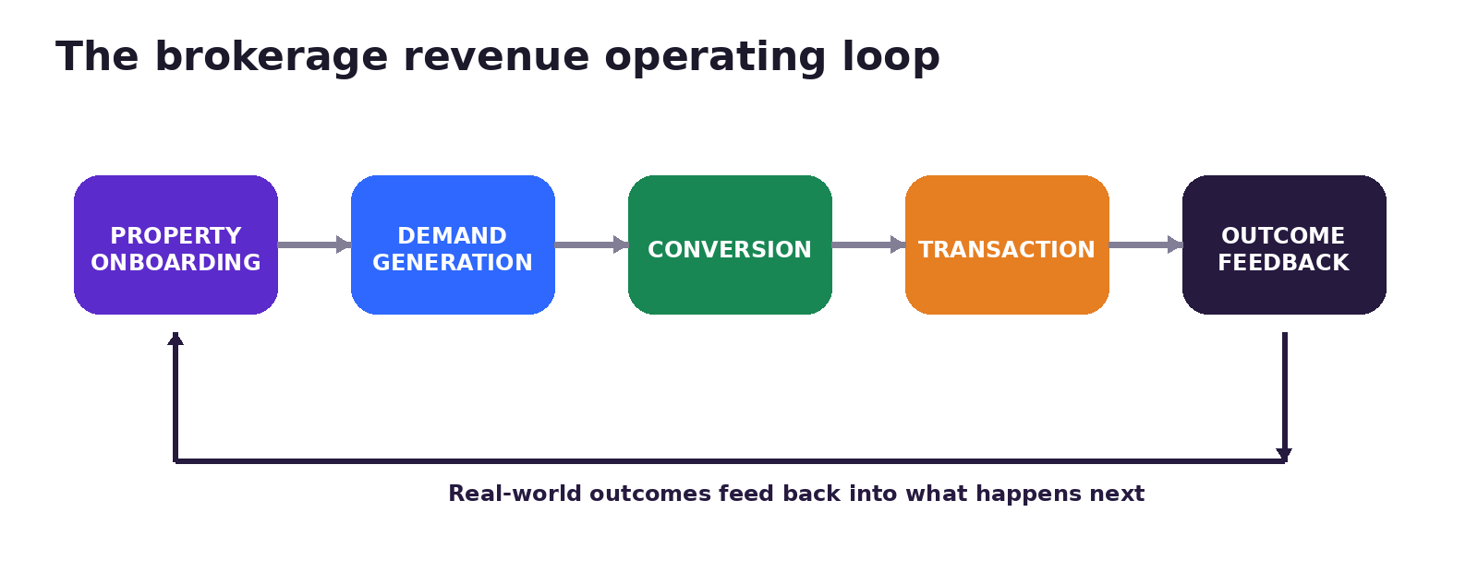
The economic loop we want Gu OS to understand and progressively operate.
This gives us a useful north star: the roadmap should not become a pile of unrelated workflows. The highest-value expansion should connect the brokerage revenue loop: Property Onboarding → Demand Generation → Conversion → Transaction → Outcome Feedback.

2. Gu today: the wedge that earned the right to expand
CURRENT
Gu entered through a concrete workflow close to revenue: moving a buyer or renter from initial inquiry toward a property visit. Gu can engage prospects, understand what they are looking for, search and match inventory, apply limited rules-based follow-up after inactivity, move conversations toward appointments, and support attendance. In the current traditional Gu system, that follow-up is still largely pre-programmed (for example, around two hours and 24 hours after a conversation stops), rather than situationally decided from durable opportunity state. Availability can be 24/7, but the brokerage controls when automation is active.
- Engage: respond when human availability is the bottleneck.
- Understand: profile intent, budget, zones, timing and relevant constraints.
- Match: search the brokerage inventory and, when permitted, shared inventory.
- Advance today: reduce reliance on human memory through limited rules-based follow-up. EVOLVE: Relationship Operations should replace fixed timers with context-aware, event-driven next-action decisions inside the Lead Opportunity Case.
- Coordinate: move toward visits, calendars and next steps.
- Extend reach: use shared inventory and integrated specialized services.
WHY THIS MATTERS
Gu is not only a prototype of a future interface. It is early evidence that customers are willing to delegate meaningful commercial work to AI when the autonomy is useful, controlled and connected to real business outcomes.

Shared Inventory is already a real capability
Ungga already imports and synchronizes customer inventory from real-estate CRMs so Gu can use it as operational knowledge. Gu can also reach beyond one brokerage when commission-sharing permissions allow it: demand from Brokerage A can be matched with a property represented by Brokerage B. The capability exists; the strategic challenge is to grow network liquidity, inventory density, geographic coverage and freshness.

3. The earned insight: real work needs more than conversation
A conversational agent can do surprisingly useful work in a single interaction. But durable business responsibility is different. When the user asks “Gu, take care of this opportunity until we get the visit” or “capture this property and leave it published,” the work survives the conversation. It may last hours, days or weeks and involve other people, external systems, waits, retries, approvals and changed facts.
That is why Gu needs both conversation and explicit operational state.
Conversation helps answer | Operational state must answer
What did the user say? | What is actually happening in the business?
What context or nuance did the user provide? | What objective are we pursuing?
What decision or correction did the user make? | What already happened and what remains?
How should Gu communicate? | What is blocked, what depends on what, and who must act?
What preferences surfaced? | What is authorized and what evidence proves completion?
What changed in the discussion? | What must be repaired if an underlying fact changes?

The conversation can guide the work. Gu OS holds the durable truth about the work.
This is the central bridge from Gu to Gu OS. Doing real work exposed the operating infrastructure an AI coworker needs in order to take on more responsibility.

4. What Gu OS is — and what it is not
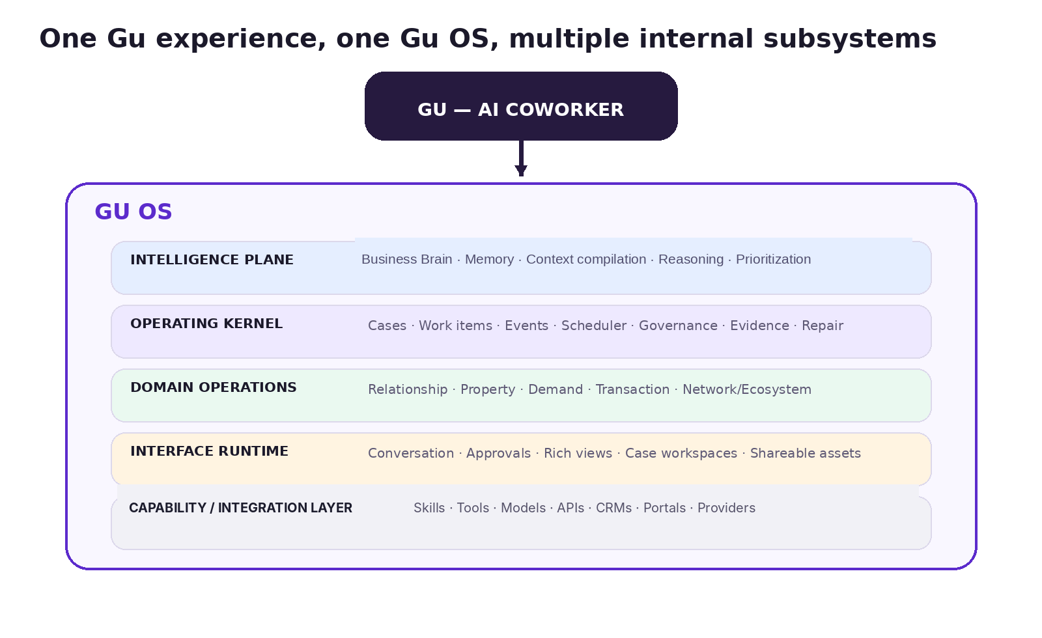
Commercially we keep one simple architecture: Ungga → Gu → Gu OS. Technically, Gu OS can contain clearly separated subsystems.
Commercially, simplicity matters. We do not need to create a family of brands such as “Gu CRM,” “Gu Network,” “Gu Brain,” “Gu Marketing,” etc. The user should mostly think: “I work with Gu.” Gu OS is the product and technical umbrella that makes the work possible.

Gu OS should be understood as a system of responsibilities
- Operating truth: explicit, durable business state rather than reconstructed chat memory.
- Execution: work items, waits, events, tools, Skills and external capabilities.
- Governance: permissions, policy, risk, human authority and auditability.
- Intelligence: context, memory, Business Brain, reasoning, prioritization and planning.
- Continuity: work that survives sessions, channels, retries, humans and changing facts.
- Outcomes: evidence that actions produced real-world results.
- Network reach: inventory, opportunities, people, systems and services beyond one brokerage.
- Interfaces: conversation plus richer views when the work requires them.
NOT A GENERIC AGENT PLATFORM
Gu OS is not primarily a toolkit for users to build arbitrary agents. It is a vertical operating environment that productizes how real-estate work can be understood, governed and executed.

5. The technical foundation that already exists
CURRENT ARCHITECTURE SNAPSHOT
The latest architecture analysis available to us describes Gu OS as a persistent multi-tenant product with a Next.js control plane, a shared LangGraph-JS agent runtime, Supabase/Postgres persistence, risk-graded tools, file-based Skills, long-term memory, multiple channels, HITL, scheduled/proactive execution and a first-class operational-case subsystem. This is a strong foundation for the direction in this document.
Current mechanism | Role in the emerging Gu OS model
LangGraph agent runtime / runAgent | Reasoning loop, tool use, checkpointable HITL, model-facing execution.
Supabase / Postgres | Durable product state, tenant-scoped records, cases, events, tool calls, messages, memory.
Operational cases | Multi-day business work with state, locking, events, waits, reminders and business HITL.
Skills | Reusable procedures and judgment playbooks with progressive disclosure.
Tools / adapters | Atomic executable capabilities with risk metadata and server-side credentials.
Memory subsystem | Cross-session semantic/procedural/episodic memory; distinct from case state.
Scheduled tasks / heartbeat / case runner | Unattended work and proactive wake-ups.
Web / Telegram / other surfaces | Multiple interaction channels over a shared governed runtime.

IMPORTANT ARCHITECTURAL BOUNDARY
LangGraph checkpoint state is execution/resume state. It should not become the authoritative business state of a lead, property, transaction or campaign. Product/business operational truth belongs in explicit domain and Case state.

The current architecture analysis also identifies important hardening work—tenant enforcement in some data paths, external-content trust, unattended completion verification, CI enforcement and single-process assumptions. These are architecture quality issues to revisit against the current repo; they are not reasons to redesign the product model from scratch.

6. Durable operational truth: what Gu should know and where it comes from
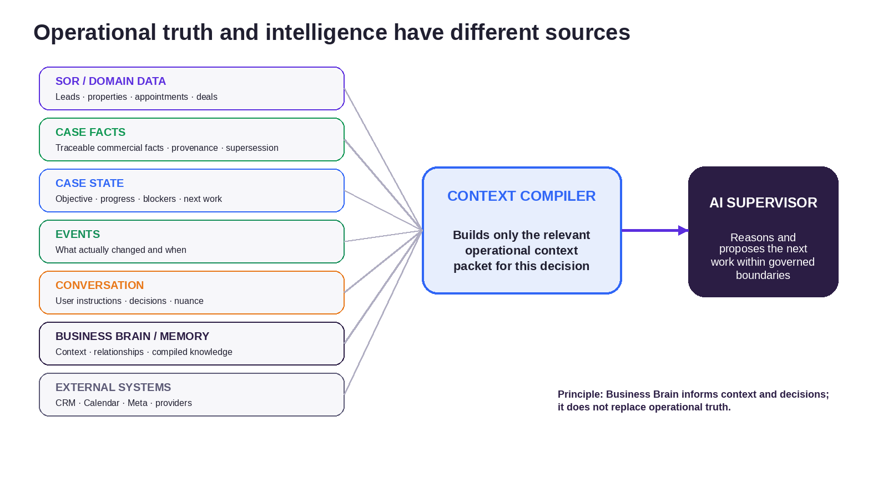
A strong Gu OS should not dump “everything” into a model. It should compile the relevant operational context for the decision at hand.
A sophisticated Gu will need access to many information sources, but they should not have equal authority. The system should preserve clear semantics about what is fact, what is memory, what is conversation, what is inferred and what is merely external context.
Information layer | Examples | Authority / role
Systems of record / domain data | users, brokerages, leads, contacts, properties, deals, appointments, messages, campaigns | Canonical transactional/structured facts for business entities; authoritative within their scope.
Case facts (`case_facts`) | commercial facts with source/provenance, confidence and supersession | Traceable commercial truth of a Case; preferred source for selective promotion into Business Brain.
Durable Case state | objective, current commitments, blockers, next_action_at, dependencies, approvals, evidence | Authoritative state of the business work.
Event history | lead_created, visit_requested, property_price_changed, approval_received | Auditable record of what changed and when.
Conversation/session | messages, user instructions, corrections, negotiation nuance | High-value context; not sufficient as operational truth.
Long-term memory | episodic, semantic, procedural memories | Useful retrieval and continuity; fallible and curated.
Business Brain | company knowledge, relationships, organizational context, compiled cross-case patterns/signals | Reusable organizational intelligence that informs decisions; not a source of operational authority.
External systems | CRM, Calendar, Meta, portals, providers | Sources/capabilities with provenance and freshness requirements.

Business Brain should inform decisions and context; it should not replace Cases, `case_facts` or systems of record.

The Context Compiler
We should avoid a “master brain” that repeatedly reads every table, every conversation, all memories and every integration. Instead, a Context Compiler should build a relevant Operational Context Packet for the current Case/decision: current case state + relevant `case_facts` / domain facts + the necessary recent conversation + relevant Business Brain/memory + policy + available capabilities + open dependencies + evidence.
The model can then reason over a concise, well-provenanced context. This is cheaper, more testable, more auditable and less vulnerable to stale or irrelevant information.

7. Operational Cases and Dynamic Workflows
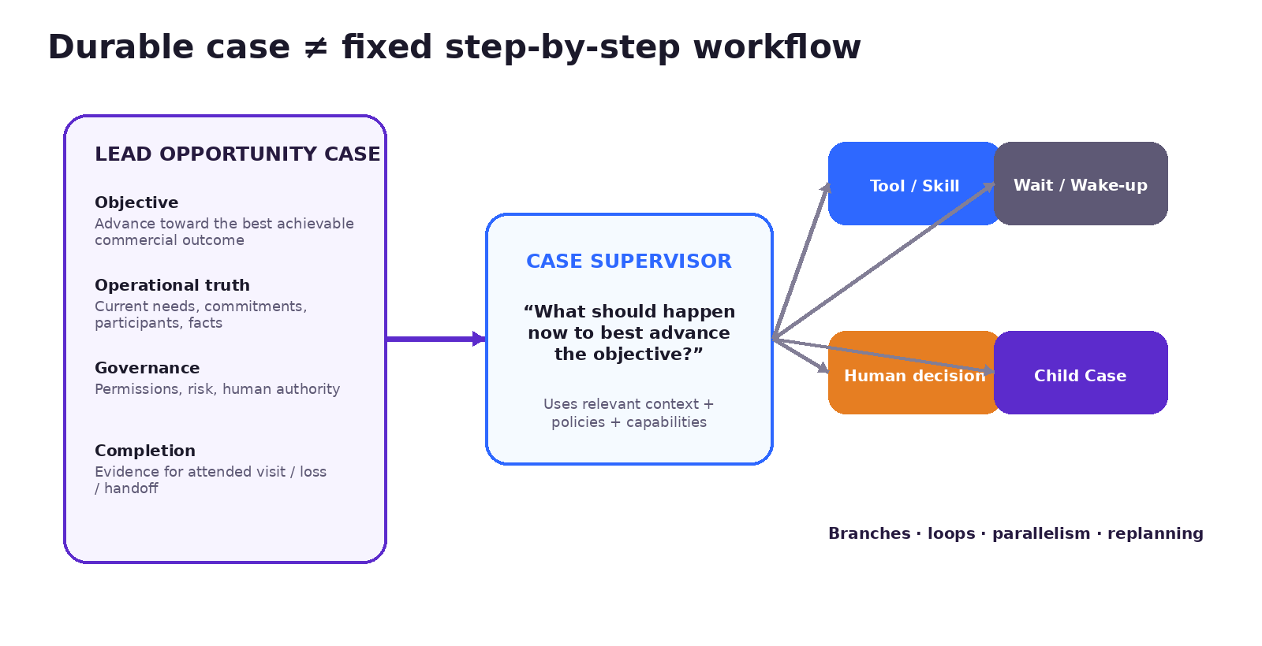
A Case can be durable while the path used to advance it remains adaptive.
A critical distinction: a durable Operational Case does not mean a rigid sequence of predetermined steps. Durability and dynamism are orthogonal.
Concept | Meaning
Operational Case | The durable business commitment: objective, operational truth, participants, constraints, governance, evidence and lifecycle.
Case type | The contract/semantics for this class of work: schemas, allowed capabilities, invariants, completion conditions, policies and context recipe.
Work graph | The actual work currently being executed or waiting inside the Case.
Dynamic workflow | A work graph that may branch, loop, parallelize, replan, create new work or involve humans as reality changes.

DESIGN PRINCIPLE
Hard where reality is hard; flexible where intelligence can choose. Permissions, economic ownership, irreversible commitments and completion evidence should not be improvised. Search strategy, follow-up strategy, investigation, decomposition and tool/Skill selection can be much more adaptive.

A Lead Opportunity Case may not know its full future sequence. It can know the objective, current relationship/opportunity state, permissions, relevant events and completion conditions. On each wake-up, the supervisor asks what work best advances the objective now.

The next work may have different granularity
- A simple tool call or deterministic lookup.
- A Skill that guides a bounded procedure or judgment.
- A durable work item with retry, dependency or waiting semantics.
- A scheduled wake-up through next_action_at.
- A human decision or approval.
- Parallel work across several independent dependencies.
- A child Case when the subproblem has its own durable lifecycle, participants, waits, authority or completion evidence.
We should not make everything a Case. Cases are valuable when the business responsibility itself deserves durable identity and lifecycle.

8. One operating core, multiple operating domains
Relationship Operations and Demand Operations should not become separate applications with their own workflow engines and then “integrate” back into Gu. They should be native operating domains inside Gu OS, reusing the same Case/work/event/governance/evidence infrastructure.
Operating domain | Business responsibility | Illustrative case types / work
Relationship Operations | Advance relationships and opportunities with leads, buyers, renters, owners and brokers. | lead_opportunity, visit_coordination, reengagement, deal progression.
Property Operations | Get inventory understood, prepared, governed and market-ready. | property_onboarding/optioning, publication, changed-fact repair.
Demand Operations | Generate and improve qualified demand tied to downstream business outcomes. | campaign_management, campaign experiment, audience/creative work.
Transaction Operations | Preserve continuity through negotiation, documents, financing/services and closing. | transaction case, financing/service coordination, closing readiness.
Network/Ecosystem Operations | Mobilize resources across brokerages and providers. | shared-inventory opportunity, network routing, service orchestration.

ARCHITECTURAL PATTERN
Shared operating primitives + domain-specific semantics. We should reuse Cases, events, work items, scheduler, policies, evidence, HITL, Skills/tools and observability—but still give each domain explicit entities, events, case types, rules and projections.

9. Relationship Operations: absorbing the real responsibility of CRM
EVOLVE — HIGH PRIORITY
Relationship Operations is the domain that most directly extends Gu’s current wedge. Its job is not to display a pipeline. Its job is to keep relationships and commercial opportunities alive and moving toward the best achievable business outcome.
Traditional CRM primarily records the relationship and exposes a pipeline. Relationship Operations is responsible for advancing the opportunity.
Here, “CRM” refers specifically to the relationship-management / lead-and-deal pipeline function of systems such as EasyBroker, TokkoBroker or Wiggot—not to Ungga’s own synchronized property inventory database. Property inventory is a separate domain responsibility: Ungga already imports and normalizes listing data so Gu can reason and act over current property knowledge, while the upstream CRM may still remain an inventory/publication source.
A Lead Opportunity Case could persist for weeks or months, especially when a buyer or renter remains commercially relevant but is not yet ready to visit, decide or transact. It might search inventory, communicate, detect a changed need, follow up, wake up when a new matching property arrives, coordinate a visit, hand off a relationship-sensitive moment to a human, or spawn a child Case when a durable subproblem emerges.
Traditional CRM interaction | AI-native Relationship Operations
User opens pipeline and scans stale leads. | Portfolio Supervisor identifies which opportunities actually need attention and why.
User creates follow-up task and due date. | Gu sets/maintains next_action_at and executes allowed follow-up automatically.
User manually updates stage. | Operational facts/events change the Case; projections summarize what matters.
User remembers what was promised. | Commitments live in explicit Case state and events.
Software suggests what to do. | Gu can act within policy; human enters only where judgment/authority matters.

This is why “CRM replacement” is the wrong question. We may need lead/contact/deal records and mission-control views more than ever. What should disappear progressively is the assumption that humans must operate those records and workflow screens to keep the business moving.

10. Demand Operations: operating acquisition, not just reporting campaigns
HYPOTHESIS / EXPANSION
Demand Operations extends Gu upstream. The target is not merely a dashboard that reports CPL or an AI that suggests better ads. The target is a governed operating domain that can pursue demand-generation objectives and learn from downstream outcomes.
An illustrative campaign_management Case could understand the target inventory and economic objective, formulate audiences/creative hypotheses, invoke Meta or other advertising rails, wait for performance data, relate generated leads to qualification/visits, propose or execute permitted budget changes, and request human authorization when a policy boundary is crossed.
IMPORTANT CONSEQUENCE
A campaign is not “successful” because it produced cheap leads. Gu OS should eventually connect campaign → lead → conversation → qualification → matching → visit request → attended visit → transaction signal, and optimize toward the downstream outcome that matters.

The same operating core supports both RO and DO. A campaign Case can generate leads that become Lead Opportunity Cases; Relationship Operations produces downstream outcomes that feed back into Demand Operations. This is the revenue loop expressed as architecture, rather than two applications connected by an integration.

11. Supervision, wake-ups and proactive work
A durable AI operating system should not require a powerful model to continuously scan every lead, property and campaign. The efficient pattern is event-driven and scheduled.
Mechanism | Question / role
Case Supervisor | For this Case, what work best advances the objective now?
Portfolio Supervisor | Across all active Cases, which ones need attention now, and why?
Business events | What changed that should wake or re-evaluate a Case?
Scheduled wake-ups | What must be reconsidered when next_action_at arrives?
Human interaction | What new instruction/decision changes the Case?
Reconciliation / supervision | What got stuck, drifted or failed to emit a clean event?

This avoids expensive “always-on thinking.” The portfolio layer can narrow hundreds or thousands of opportunities to a small set of Cases where something changed, a commitment is due, a timer fired or attention is warranted. Only then do we pay for deeper case-level reasoning.
This is an important evolution from the current Gu lead-follow-up behavior. Today, a few fixed inactivity timers can create the appearance of proactivity, but they do not constitute situational opportunity management. The Gu OS target is different: events, durable Case state, delivery/contact policies, next_action_at wake-ups and case/portfolio supervision should determine whether follow-up is needed, when it should occur, what it should say or do, and whether Gu can execute autonomously or should involve the real-estate professional. The existing Gu OS foundations make this evolution possible; the Lead Opportunity Case and its domain logic still need to be implemented and validated.
LLM ROLE
The model should reason and choose strategy within a bounded action space. Gu OS—not the model—should remain the authority for permissions, invariants, durable commitments, idempotency, approvals and verified state transitions.

12. Business Brain, memory and company-specific intelligence
Business Brain should be treated as the target internal intelligence layer within Gu OS, not as a separate product brand. Its purpose is to help Gu understand the particular company it works with: people, relationships, company knowledge, historical decisions, ways of working, important signals and eventually patterns that can improve future judgment.
Terminology boundary: the current `business_brain` JSONB/memory mechanisms are limited implementation surfaces, not the whole target architecture. “G Brain” is a reference architecture/inspiration used in our analysis, not the canonical name of the Gu OS subsystem. In this document, Business Brain refers to the target Brain Layer.
That intelligence complements rather than replaces Cases, `case_facts` or systems of record. A memory may say that a broker usually prefers afternoon appointments; the appointment record must still be the source of truth for the confirmed visit. Business Brain may know that a manager usually approves certain exceptions; authorization for this specific Case must still be represented by policy or an explicit decision.
Knowledge / memory layer | Best use
Session/conversation context | Immediate interaction and nuance.
Episodic memory | Relevant events or experiences that may matter later.
Semantic memory | Durable facts/preferences not better represented in canonical domain data.
Procedural memory | Ways of working and reusable preferences/procedures.
Business Brain / organizational knowledge | Richer relationships, business context, compiled knowledge, signals and cross-case intelligence.
Case state / case facts / events | Authoritative responsibility/state, traceable Case facts and auditable change history.

The compounding thesis is not “store more chat.” It is: more work → richer business context + operating patterns + outcome evidence + trust → better decisions/execution → more work delegated.

13. Governed autonomy: Humans lead, Gu gets work done
AI-native does not mean “maximum autonomy.” It means giving the system real responsibility where it can act safely and economically, while preserving human authority where relationships, judgment, risk or accountability matter.
Decision class | Expected behavior
Routine operational | Gu may understand, decide and execute within policy.
Relationship-sensitive / strategic | Gu analyzes and recommends; human leads or decides; Gu executes consequences.
High-risk / authority-sensitive | Gu prepares context; human authorizes; Gu resumes and verifies execution.

Human involvement: the runtime taxonomy
The decision-class table above is a product/business lens for how much autonomy is appropriate. It is not the runtime taxonomy of human participation. The canonical umbrella in the technical plan is human involvement.
What is requested from the human:
- A. Action / tool authorization — Can Gu execute this side effect? Examples: a medium/high-risk tool, publishing, sending an email.
- B. Business decision — Which commercial or legal outcome does the human choose? Examples: price, contract, publication destination, ownership override.
- C. Human contribution / task — What information or action must the person supply? Examples: documents, photos, a missing field, OTP/CAPTCHA, owner response.
- D. Exception review / intervention — What should happen after failure or ambiguity? Examples: verifier failure, blocked work item, publication incident.
How the human participates:
- HITL blocking — the runtime pauses until a response is received.
- Human as executor — a work item is assigned to a person; the human performs the work rather than merely approving it.
- Human-on-the-loop — the person supervises or intervenes without blocking every step.
These are two independent axes: what is needed from the human and how the human participates. Not every human contact is HITL.

A critical engineering principle follows: “The prompt guides; verification governs.” A model saying “done” cannot be the completion criterion for consequential unattended work. Evidence, acceptance criteria and changed-fact repair become first-class product mechanisms.

Selective repair when facts change
If a property price changes after an approval, commercial package and publication were created, Gu OS should be able to identify which prior work consumed the old fact and selectively invalidate or repair the affected artifacts. Photos or ownership documents may remain valid while price approval, listing copy or portal publication may require repair. This is a much stronger model than asking the LLM to reconstruct the past from chat history.

14. Skills, tools, cases and external capabilities
The architecture is strongest when each mechanism has a clear job rather than everything becoming a prompt or a workflow.
Mechanism | Use when... | Example
Tool | A bounded atomic action or read can be expressed with a stable contract. | Search listings, read calendar, call valuation API.
Skill | Judgment/procedure benefits from a reusable playbook and progressive disclosure. | Buyer qualification, document review approach.
Work item | Work must persist/retry/wait/depend on something. | Obtain seller availability, await document.
Operational Case | The business objective deserves durable identity/lifecycle and governance. | Lead Opportunity, Property Onboarding, Campaign Management.
Child Case | A subproblem has its own objective, waits, participants or completion. | Visit Coordination or Financing within a larger opportunity.
External provider | Specialist execution is modular and does not need to be Ungga’s moat. | Avaclick valuation, MICA screening, Meta media rails.

Multi-agent architecture is not required to achieve this. A single Gu experience can mobilize many Skills, tools, workers and Cases underneath. Specialized subagents should be introduced only where parallelism, isolation or materially different models produce sustained value—not because “multi-agent” sounds more advanced.

15. UI/UX: one continuous Gu relationship across surfaces
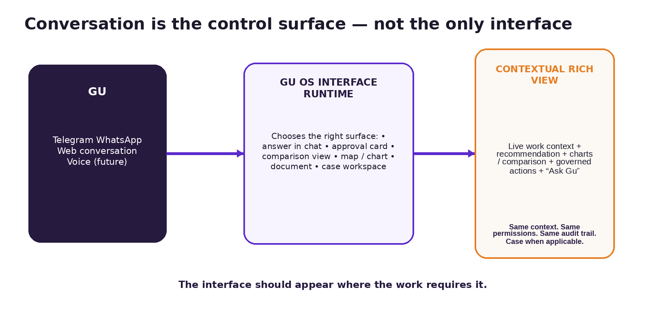
Conversation remains central, while richer interfaces appear only when the work benefits from them.
Telegram, WhatsApp and chat are excellent for dialogue, notifications, short explanations and approvals. They are poor for comparing campaigns, inspecting large tables, reviewing charts, exploring maps, or working through complex documents. We should not force everything into chat.
The target pattern is: conversation is the primary control surface; Gu decides when a richer contextual view is necessary and sends the user to a secure web view tied to the same work context —and to the same Case when one exists— with its permissions and audit trail.
UI object | Typical lifecycle
Prebuilt view | A carefully designed reusable interface such as Campaign Performance, Lead Portfolio or Approval Center.
Generated composition | Gu selects from trusted components to assemble a context-specific view.
View instance | A live context-specific view that may be ephemeral, persist for the work context, or persist for the Case lifetime when a Case exists.
Snapshot / evidence artifact | Immutable representation of what was shown/approved at a consequential decision moment.
Published / shareable asset | Explicitly versioned, permissioned, revocable output intended to be shared.

The interface should appear where the work requires it.
Initially, we should prefer trusted components and schema-driven composition rather than allowing the model to generate arbitrary React applications. Flexibility can be high while security, testing, accessibility and consistency remain under engineering control.

16. What Ungga should own — and what it should orchestrate
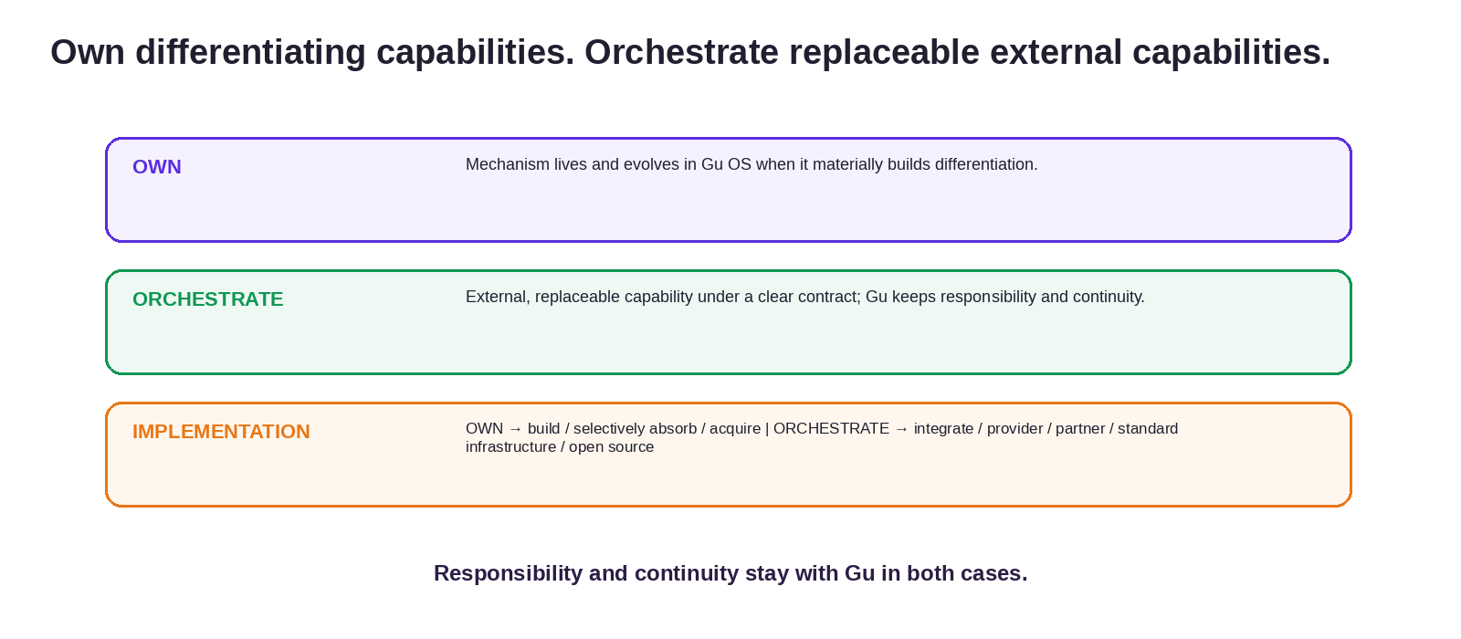
Verticalization should separate the strategic ownership decision from the implementation choice. Gu retains responsibility and continuity of the work in both OWN and ORCHESTRATE.
Level 1 — OWN vs ORCHESTRATE. OWN when the capability’s mechanism must live and evolve inside Gu OS because it materially builds differentiation. ORCHESTRATE when the capability can remain external and replaceable under a clear contract without losing continuity, context, governance, evidence or learning about the work.
Level 2 — implementation. If we OWN a capability, we can build it, selectively absorb it or eventually acquire it. If we ORCHESTRATE it, we can integrate through API/MCP/webhook/etc. and obtain it from a provider, partner, standard infrastructure or open source. Valuation today is a useful example: Avaclick can remain the orchestrated specialist engine while Gu OS retains context, inputs, approvals, acceptance/impact, Case consequences and repair. Only if the valuation capability itself becomes a material source of differentiation should we reconsider owning it.
STRATEGIC PRINCIPLE
OWN the capabilities that build differentiation. ORCHESTRATE external, replaceable capabilities. Gu retains responsibility and continuity of the work in both cases. Build/absorb/acquire vs integrate/provider/partner are implementation choices underneath.

17. CRM strategy: decompose the problem instead of “replace vs. integrate”
In Mexico/LatAm, the term “real-estate CRM” often bundles several different jobs. Based on Ungga’s field experience, small brokerages frequently value these systems most for property inventory/publication and brokerage exchange, while relationship-management functions are often less deeply operated. This is a working market insight, not yet a quantified public claim.
Job hidden inside “CRM” | Recommended direction
Relationship / pipeline responsibility | OWN / absorb the differentiating Relationship Operations capability in Gu OS. Preserve records and mission control, but reduce manual software operation.
Property inventory source | OWN the normalized property semantics/model Gu needs; ORCHESTRATE / INTEGRATE upstream inventory sources while they remain useful and replaceable.
Portal syndication | ORCHESTRATE external portal rails. Gu retains publication context, intent, policy, status, retries, evidence and downstream consequences.
External brokerage exchange / bolsa | ORCHESTRATE / INTEGRATE external brokerage exchanges while they contribute valuable, replaceable liquidity and geographic coverage.
Ungga Shared Inventory | OWN + SCALE LIQUIDITY. Shared Inventory is a strategic network capability; the challenge is density, freshness and participation.

The relationship-management responsibility is different. Gu should not depend on a human updating a third-party pipeline correctly to know which prospect deserves action. That operating responsibility belongs close to Gu OS.

18. Shared Inventory, B2B2C and future consumer discovery
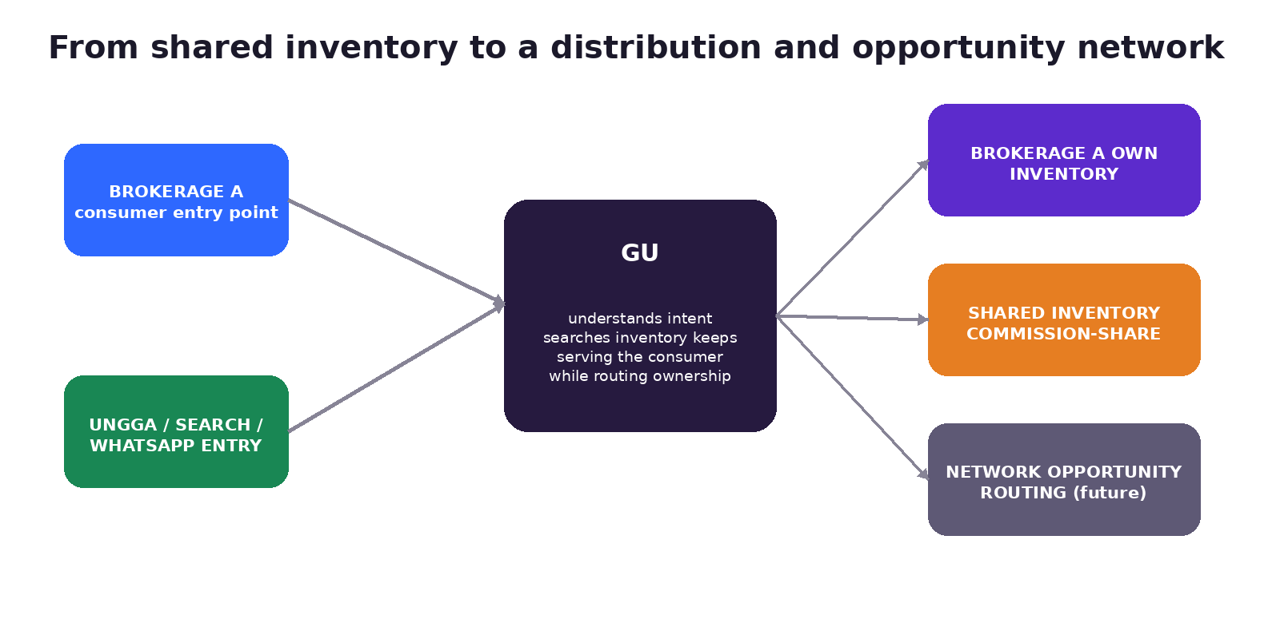
The mechanism already exists in early form; the strategic opportunity is to turn it into a distribution/network flywheel.
Today, a prospect can enter through a brokerage’s Gu experience, search that brokerage’s inventory first, and—when permitted—reach commission-shareable inventory from the wider Ungga network. That is already an early B2B2C mechanism.
The next strategic step is not necessarily a consumer app. Buying or renting is episodic, so the buyer is more likely to arrive through Google/search, an AI search surface, a property page, social media, a brokerage website, WhatsApp, Telegram, a referral or a shared link. Gu should be channel-native and preserve a persistent property-search relationship without requiring an app install.
If a consumer originates directly through Ungga rather than through a participating brokerage, Gu can continue serving that consumer while the network resolves which broker/property should receive the opportunity. That creates room for future Network Opportunity Routing based on representation, commission-sharing, geography, service-level rules, capacity and relationship ownership.
NETWORK GOVERNANCE MATTERS
The LLM should not improvise economic ownership. Lead attribution, representation, commission-sharing, broker priority, claim windows and routing policies should be explicit governed rules.

Consumer marketplace/discovery is therefore a density-gated strategic option. We should not try to become “another portal with better filters” before supply quality and local liquidity justify it. A better thesis is conversational, persistent discovery connected directly to visits and downstream outcomes.

19. Current vs. evolving vs. future — do not mix them
A credible team needs a shared understanding of what already exists versus what we are proposing. The table below is a direction map, not a committed roadmap.
Area | CURRENT / evidence | EVOLVE / target | Longer-term / hypothesis
Gu experience | Lead engagement, matching, limited rules-based follow-up, visits; multi-channel surfaces. | More cross-workflow delegation; richer contextual interfaces. | One persistent AI coworker across the company.
Operating core | LangGraph runtime, HITL, operational cases, events, waits, scheduling, Skills/tools. | More dynamic work graphs, supervisors, broader human-involvement patterns, outcome/evidence hardening and stronger context compilation. | Broad reusable operating kernel across domains.
Relationship Ops | Traditional Gu already performs meaningful conversion work. | Lead Opportunity Cases, next-action engine, portfolio supervision, deeper outcome state. | Company-wide relationship/opportunity operations.
Property Ops | Property Optioning / durable workflow foundation; inventory sync; shared inventory. | Normalized property state, selective absorption, richer repair and publishing orchestration. | Broader property lifecycle operations.
Demand Ops | Source information exists in parts; demand generation not yet operating end-to-end. | Campaign-management Cases and downstream attribution experiments. | Continuous demand optimization tied to visits/transactions.
Business Brain | Existing memory and limited `business_brain` mechanisms; broader Brain Layer not yet implemented. | Context Compiler, richer relationships/provenance, signals and compiled cross-case company knowledge. | Governed organizational learning/improvement.
Network | Shared inventory and integrated services already exist. | Grow liquidity/density; opportunity routing rules. | Broader real-estate operating network.

20. What this means for how we build
1. Start from business responsibility and outcome, not from a feature or a screen. Ask: what real work should Gu become responsible for?
2. Define the operational truth before designing the prompt. What must be persisted explicitly for the work to survive sessions, humans and changed facts?
3. Reuse the Gu OS operating core. New domains should add semantics, case types, Skills, tools, events and projections—not their own isolated workflow engines.
4. Keep the model powerful but bounded. Let it reason where judgment is valuable; enforce authority, commitments, evidence and safety in deterministic layers.
5. Treat UI as a surface over the same work context —and the same Case when one exists. Avoid creating disconnected mini-apps whose actions bypass Gu OS governance.
6. Prefer replaceable external capabilities where their mechanism does not need to be owned for differentiation. Keep the work context, governance, evidence, consequences and learning inside Gu OS.
7. Design for outcomes, not activity. “Message sent” is not success; “visit attended” or another verified business result may be.
8. Use progressive disclosure and context compilation. Do not solve every problem by giving the model more tokens.
9. Build network rules as product infrastructure. Ownership, commission-sharing and routing need explicit governance.
10. Be precise about current vs target. Product ambition is an advantage only if we remain honest about what has been validated.

21. Questions we should answer together in the sessions
The purpose of the pre-read is not for everyone to agree immediately. Please arrive ready to challenge the model. These are the questions I would want the team to discuss first:
1. Which parts of the current Gu lead engine can be reused inside Relationship Operations, and which fixed/rules-based behaviors should be replaced by durable, event-driven Lead Opportunity logic?
2. What data do we currently treat as conversation/memory that should instead become explicit `case_facts`, Case state or remain in a system of record?
3. How should a Lead Opportunity Case be created, linked to existing lead/conversation records and completed?
4. Where does the current operational-case infrastructure assume a predetermined transition graph, and where can we safely introduce dynamic work graphs?
5. What should the Case Supervisor be allowed to decide automatically versus what remains deterministic or human-authorized?
6. What events and wake-ups are missing for proactive opportunity operation?
7. Which outcomes can we verify today (visit requested, scheduled, attended, transaction) and where are the data gaps?
8. Which CRM capabilities should we OWN / absorb, which should remain ORCHESTRATED through upstream integrations, and what is our canonical normalized property model?
9. What first rich views would create the most value: Lead Portfolio, Campaign Analysis, Property Onboarding, Approval Center, something else?
10. What current architecture risks/hardening items have changed since the July architecture analysis, and what must be revalidated in the repo?
11. What is the smallest high-value next operating domain we can build without turning Gu OS into bespoke consulting?
12. What metrics would prove that the new operating responsibility is valuable enough for customers to delegate more work to Gu?

22. Working glossary
Term | Working definition
Gu | The AI coworker / identity the user works with.
Gu OS | The operating system behind Gu: the governed environment for understanding, coordinating and executing real-estate work.
Operational Case | A durable business objective/commitment with explicit state, participants, governance, evidence and lifecycle.
Case type | Reusable operational contract for a class of Cases.
Dynamic workflow / work graph | Adaptive work inside a Case; may branch, loop, parallelize or replan as reality changes.
Work item | A persistent unit of work with status/dependencies/retry/wait semantics.
Skill | A reusable playbook that guides judgment/procedure.
Tool | An atomic executable/read capability with a stable contract.
Business Brain | Target Gu OS intelligence layer for company-specific context, relationships, signals, compiled knowledge and cross-case intelligence. Distinct from current limited `business_brain` implementation surfaces and from operational truth.
Operational truth | The explicit durable representation of what is actually happening in the business.
Context Compiler | Mechanism that assembles the relevant context packet for a decision/Case without dumping all available information.
Relationship Operations | Gu OS domain responsible for advancing relationships/opportunities, not merely storing them.
Demand Operations | Gu OS domain responsible for generating and improving qualified demand tied to downstream outcomes.
Portfolio Supervisor | Layer that determines which Cases across a portfolio need attention now and why.
Case Supervisor | Layer that decides what work best advances one Case now, within policies and capabilities.
Contextual / Dynamic Interface | A richer UI surfaced when the work requires it, tied to the originating work context —and to the Case when one exists— with consistent permissions and auditability.
Shared Inventory | Ungga’s existing mechanism for matching demand with commission-shareable inventory across participating brokerages.
Governed autonomy | Gu can act independently inside explicit policy/authority boundaries and escalates when human judgment/authorization is required.
Case facts (`case_facts`) | Traceable commercial facts of a Case with provenance/supersession; distinct from Case state and transactional systems of record.
Human involvement | Umbrella taxonomy for when a person is needed, what is requested, and how the person participates; HITL is only one mode.

23. The direction in one page
We started with Gu doing one economically meaningful job: helping real-estate teams convert incoming demand into visits. That work exposed a broader truth: if an AI coworker is going to take on durable business responsibility, chat history cannot be the operating system.
Gu OS is our answer: one governed operating environment where business state, Cases, `case_facts`, events, Skills, tools, memory, Business Brain, human authority, evidence, interfaces and network capabilities can work together. The same core can support multiple operating domains instead of producing another collection of fragmented SaaS applications.
Relationship Operations is the clearest near-term expression of this idea: do not rebuild CRM screens; absorb the responsibility of keeping opportunities alive and advancing them. Demand Operations extends the same operating model upstream. Property, Transaction and Network Operations can use the same primitives as they mature.
The user should not need to understand any of this complexity. They should experience one Gu that understands context, brings the right interface when needed, uses the right capability, asks for human judgment when appropriate, and keeps the work moving.
One Gu. One operating system. More of the real-estate operation progressively delegable to AI.
OUR STRATEGIC DISCIPLINE
Own the capabilities that build differentiation. Orchestrate external, replaceable capabilities. Gu retains responsibility and continuity of the work in both cases; implementation choices sit underneath that strategic boundary.

If we keep that distinction clear, Gu OS can become something substantially more valuable than another AI feature layer: an AI-native operating environment that allows real-estate companies to increase productive capacity without requiring operational headcount and coordination cost to grow proportionally.

Sources and status note
This document synthesizes three kinds of material: (1) the Ungga Investor Narrative Backbone v0.6, which captures the current business/product thesis; (2) Gu OS Agent Architecture Analysis, a code/documentation-based architecture review at repository commit b465151d… (2026-07-14) using the “Dive into Claude Code” paper as an analytical lens; and (3) subsequent internal working discussions in August 2026 around Relationship Operations, Demand Operations, dynamic Cases/workflows, Business Brain (with G Brain as an architectural reference), contextual interfaces, CRM decomposition, shared inventory/network strategy, human involvement and the two-level OWN/ORCHESTRATE framework (POSEER/ORQUESTAR in Spanish-facing materials).
Important: the architecture analysis explicitly did not perform runtime verification and predates later Gu OS work. Therefore, implementation-specific statements in this pre-read should be revalidated against the current repository before we freeze the technical deep-dive or roadmap. Strategic/target sections are intentionally labeled as EVOLVE, HYPOTHESIS or VISION.
Key internal references: Ungga Investor Narrative Backbone v0.6; Gu OS Agent Architecture Analysis; current Gu/Gu OS codebase and architecture manuals; latest OWN / ORCHESTRATE decision framework.

